- Create EC2 Service instance on AWS Console side.
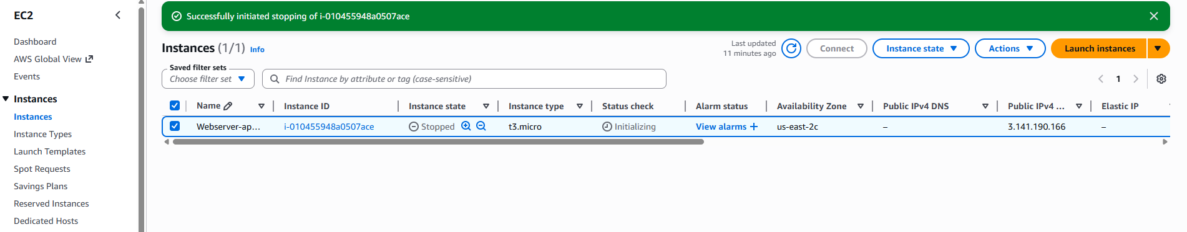
Open BigBash
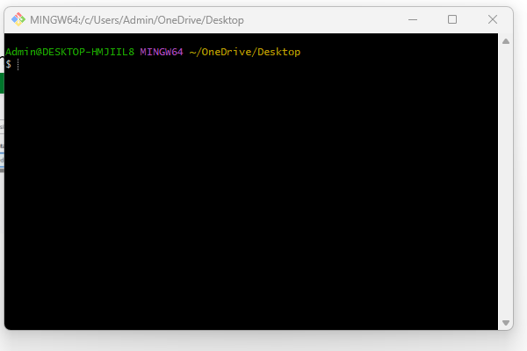
Connect to EC2 Instance using ssh -I command. Note Your key file(Linux-test2) is in same foder where you open your Gitbash path.
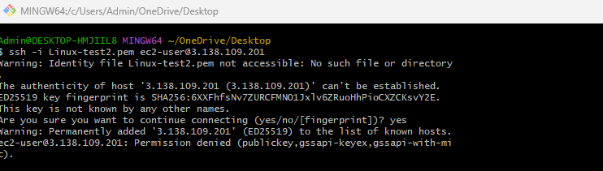
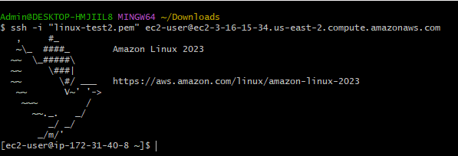
Now your instance is connected to your EC2.

- How to install Apache?

Asking for size permission?
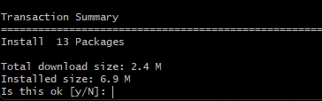
Now installation is done
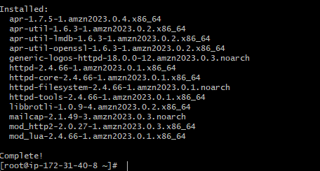
If you want to check service is running or not.
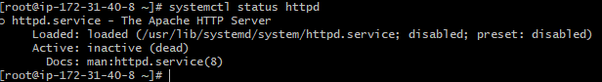Now status is inactive. To make active we need to run below command
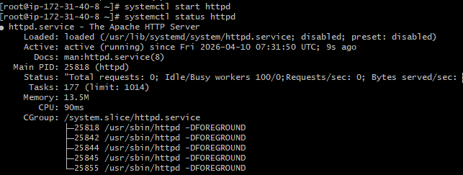

Check with port no
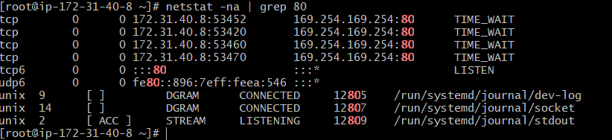

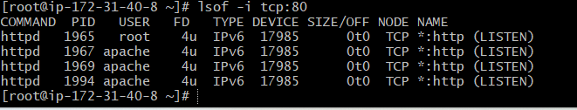
Check service with httpd using below command.
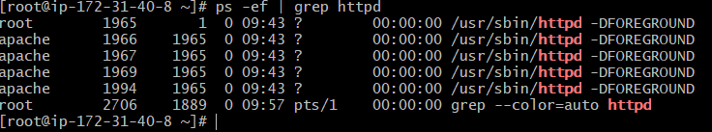

Open in browse to httpd
Create inbound rule on AWS ec2 Instance
Then work on browser
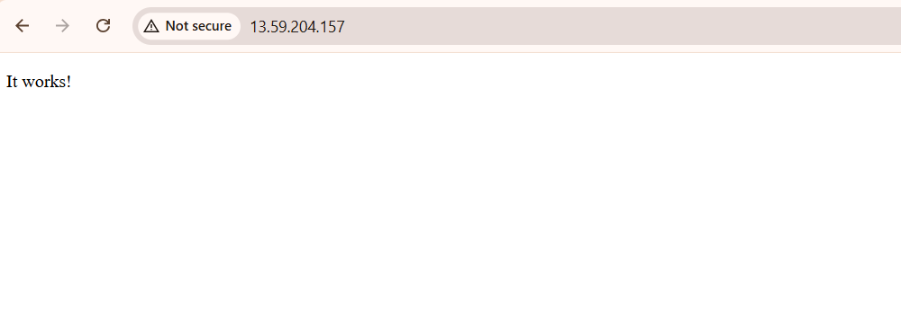
To change port no 80 to 82
Find httpd.conf file
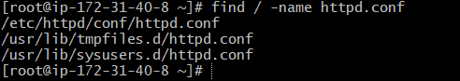
Read the content of /etc/httpd/conf/httpd.conf file
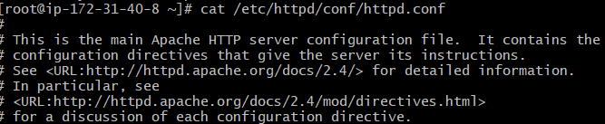
Before making changes any file make backup of file.
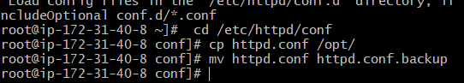
Open file in vi Editor and change port no 80 to 82.
 To
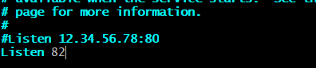
Run on port no 82


- How to install Nginx
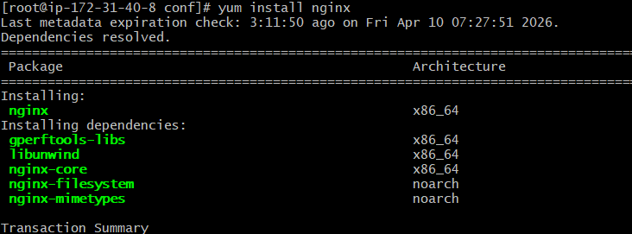
Ask for size permission after given permission. Then nginx is installed.
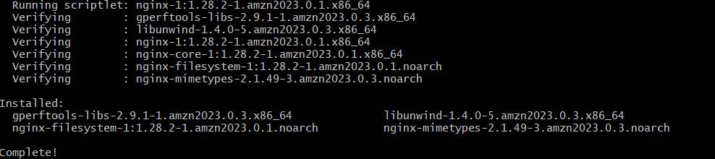
Now we check status and start the service on port 80
Now we change port 80 to 81
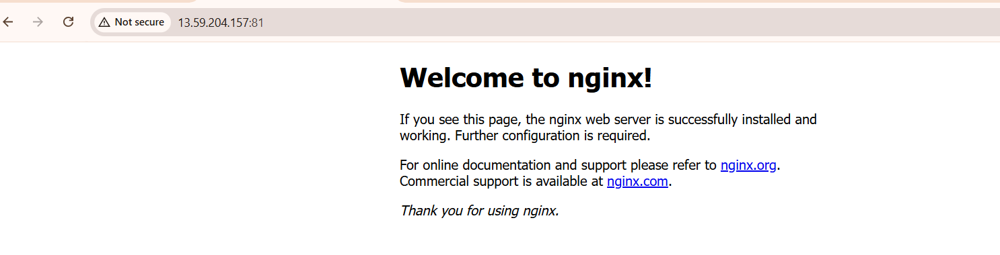

- Deploy a sample index.html file on Apache.
Go to default path of deployment is /var/www/html/
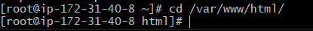
Check any file is available or not using ll command.
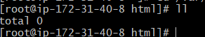
There is no file then create file with name index.html using touch index.html command. Also
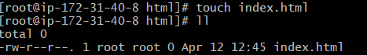
Now Edit that file with some text, using vi index.html command.
Now check using browser file Is run or not.


- Deploy a sample index.html file on nginx.
Start nginx server first using(systemctl start nginx) & check status of nginx using( systemctl status nginx) command.
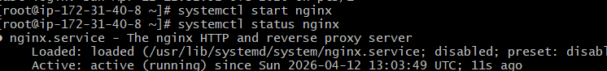
Go to default location using cd /usr/share/nginx/html/
Check any file is available or not using ll command.
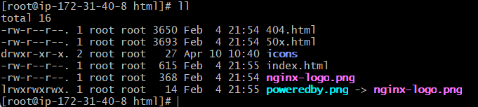
There is file available index.html so you no need to create file need change that file using vi index.html command.
Now check using browser public IP and port no.
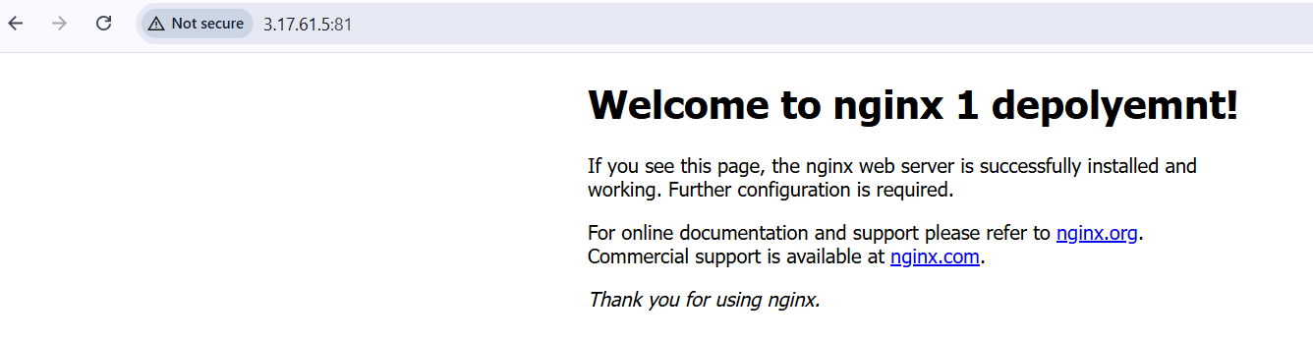
- Install Apache tomcat on port number 8082
How to install Apache tomcat using yum install tomcat. I get issue below
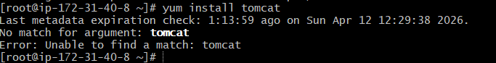
First need to install jdk using yum install java-1.8.0-openjdk -y command
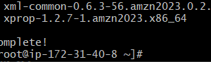 After install Jdk

Now I update system using yum update -y
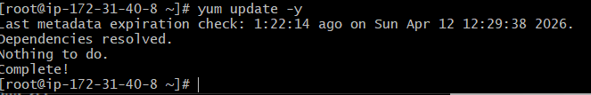
Need to install manually goto apache tomcat web site browse download link
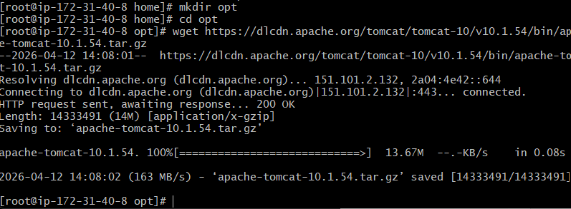
Now file is downloaded Opt directory.Now decompress the file using tar -xvf filename command
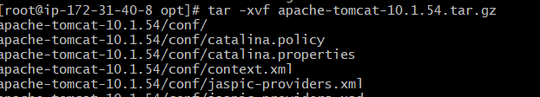
Goto in bin folder.using cd bin command
Run ./startup.sh file.
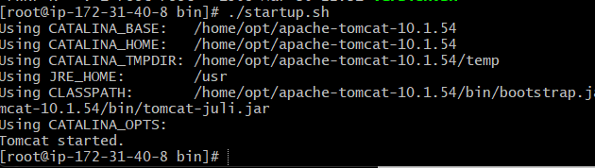

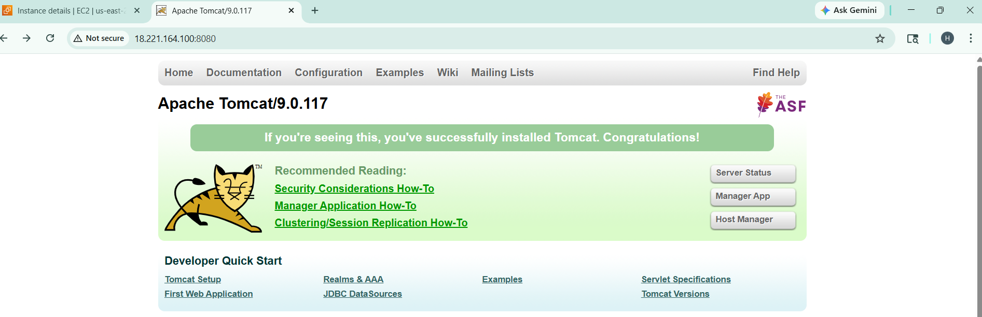
Now change port 8080 to 8082
First goto path where apache tomcat file decompose.
Using vi, vi server.xml using this command open server.xml file.
Change port no
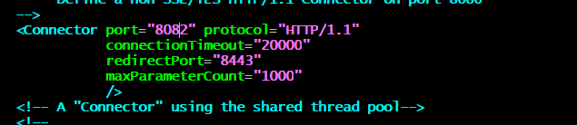
Restart service using systemctl restart tomcat command

Enable inbounds rule in EC2 instance
Now it is working on 8082 port
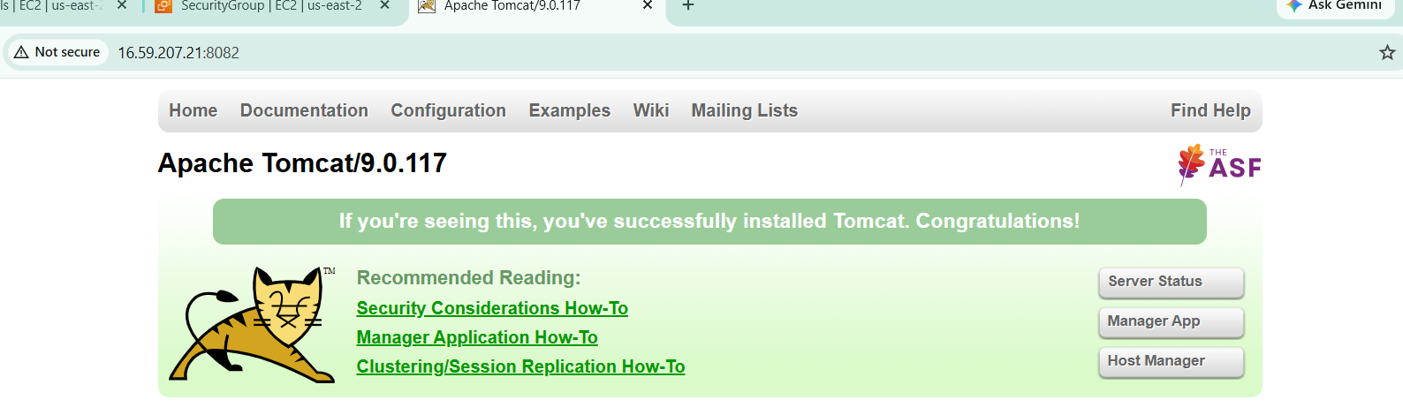

- Create a tomcat.service file for tomcat.
First goto cd /etc/systemd/system/ directory

Create file tomcat.service. using touch command write code
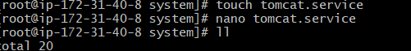

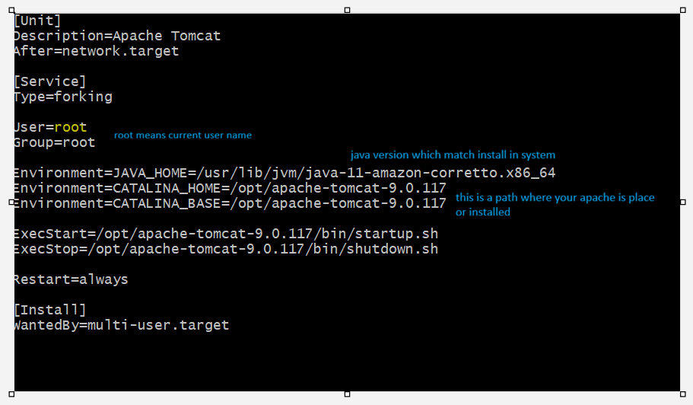
Check file is created or not using ll command
After create service file use below command
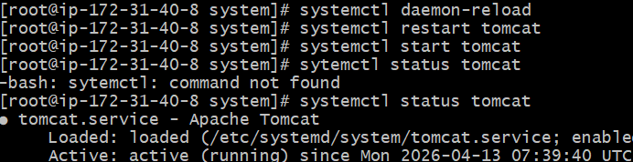
Run apache tomcat on browser using port no 8080

- Deploy a sample app on webapps?
First download website using this link https://tomcat.apache.org/tomcat-6.0-doc/appdev/sample/ download and copy this folder in webapp folder using wget command.
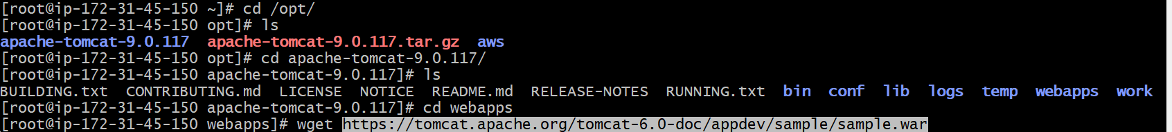
After that file is downloaded on webapps directory. Got webapps directory and check file is downloaded or not.
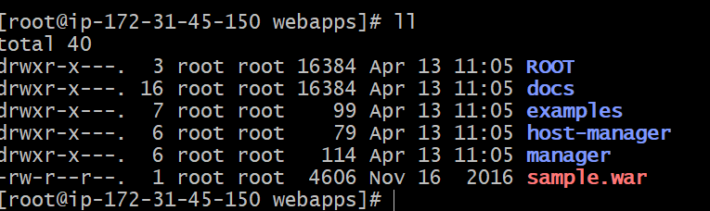
Create one directory using mkdir simple folder name.
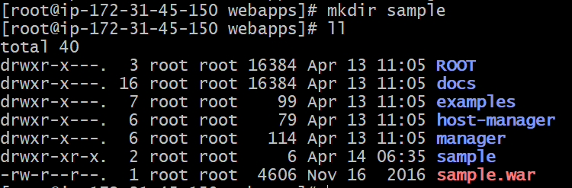
Now copy sample.war file in sample folder. Using
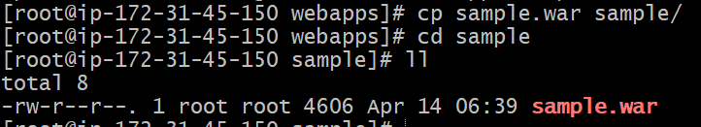

After that use unzip filename.war command to extract sample.war file.
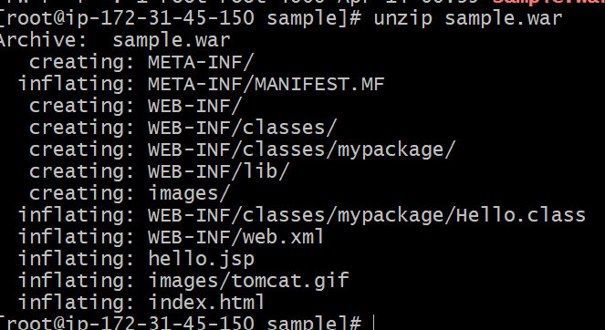
Now check file is extracted or not. Using ll command.
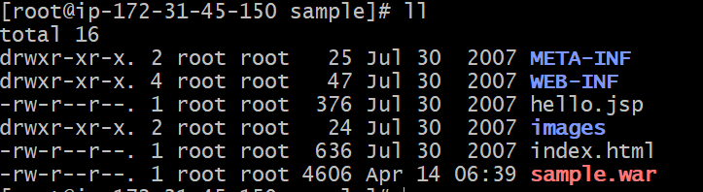
Now open browser pase url and check website is running or not?
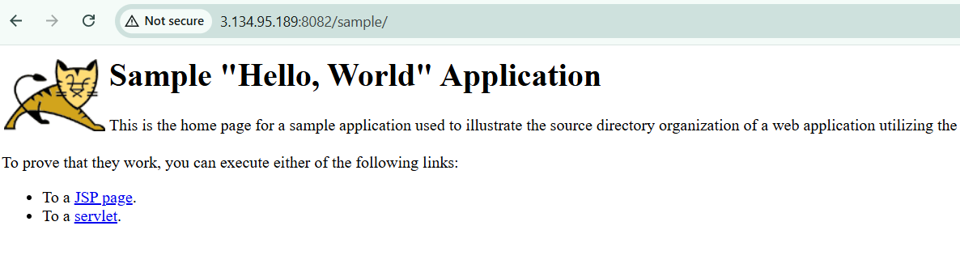
- Configure HA Proxy server
Create Server-1, Server-2 and HA-Proxy-Server on EC2 instance

Run following command to Access the Server-1
ssh -i "amazonkey.pem" ec2-user@ec2-18-220-98-133.us-east-2.compute.amazonaws.com
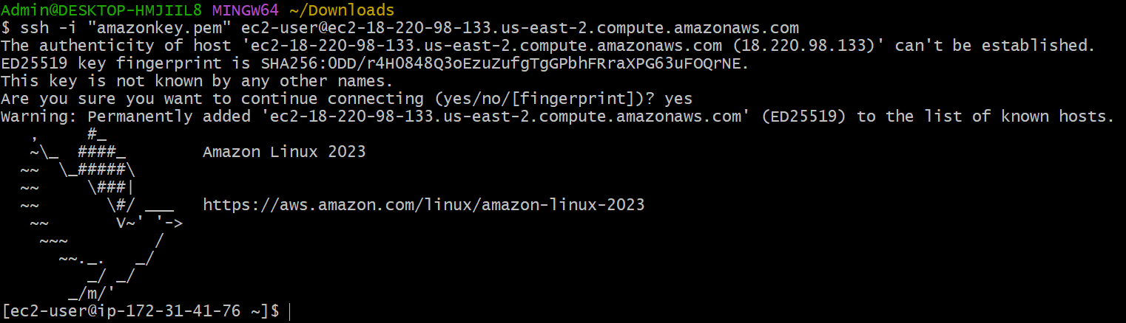
Sudo -I To change User
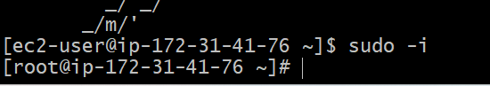
Use yum update -y. command to update system.
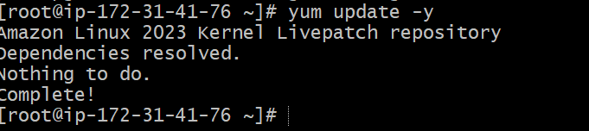
Yum install httpd -y
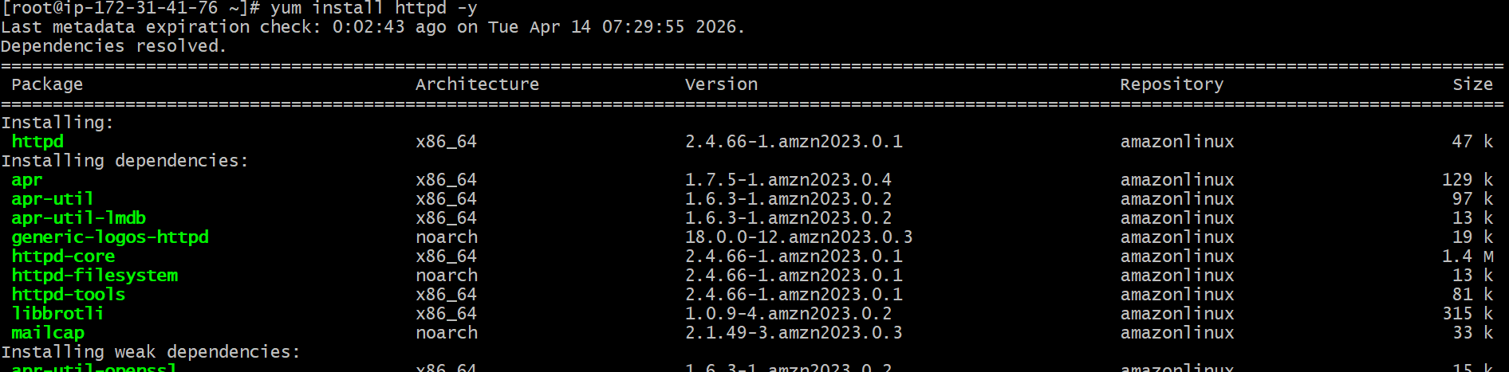
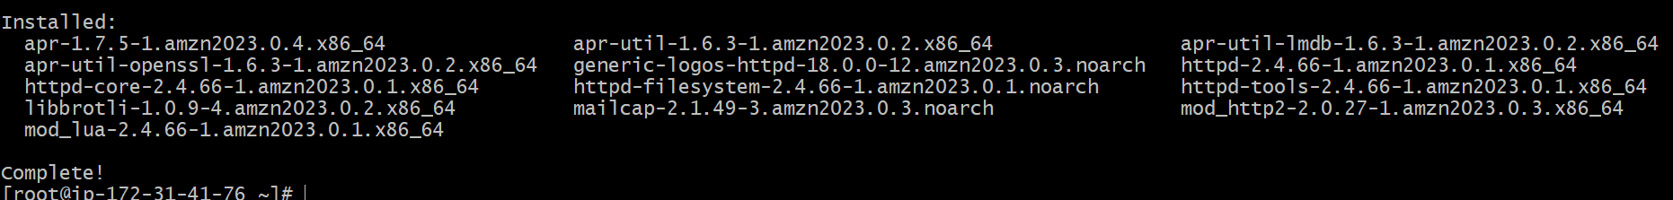
Vi /etc/hosts
Add HA-Proxy-Server Pubic IP Address(add in last ServerIP Address and load_balancer)
Run below command on Server-1
ping load_balancer -c 4
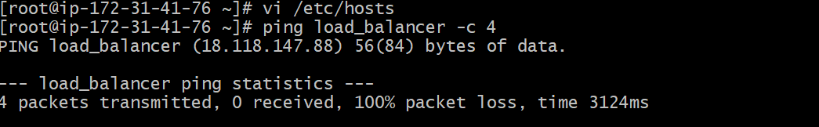
systemctl start httpd
systemctl status httpd
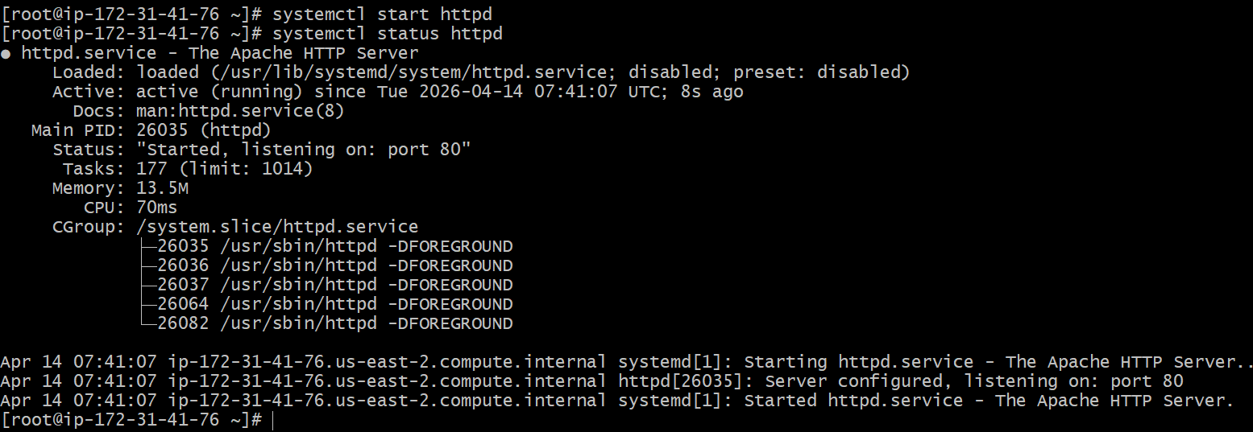

Browse with Server-1 Public IP address:80 it will work
Server-2 Steps:
Run following command to Access Server-2
• ssh -i your-key.pem ec2-user@Pubipaddress of Server-2 instance
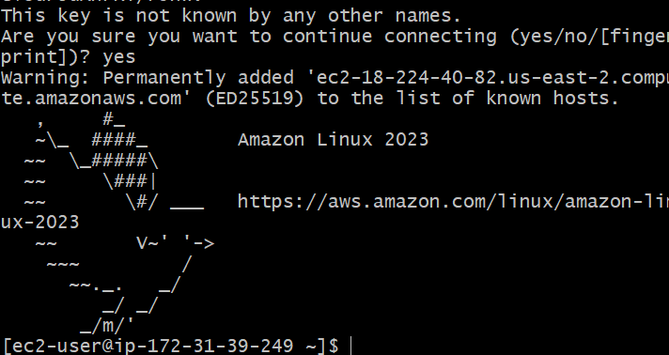
Usdo -i
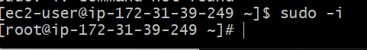
yum update -y
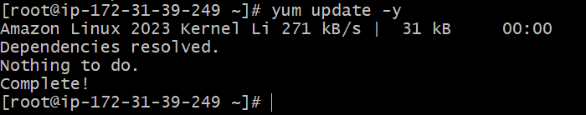
yum install nginx -y
sudo amazon-linux-extras install nginx1 -y
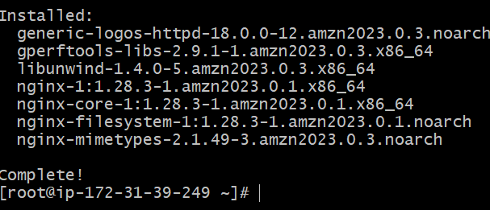
vi /etc/hosts
Add HA-Proxy-Server Pubic IP Address 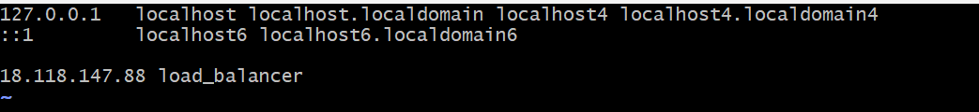
Run below command on Server-2
ping load_balancer -c 4
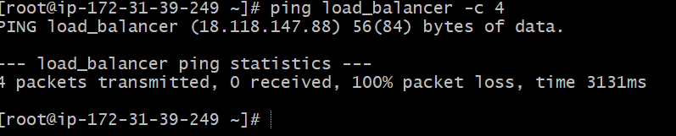
systemctl start nginx
systemctl status nginx
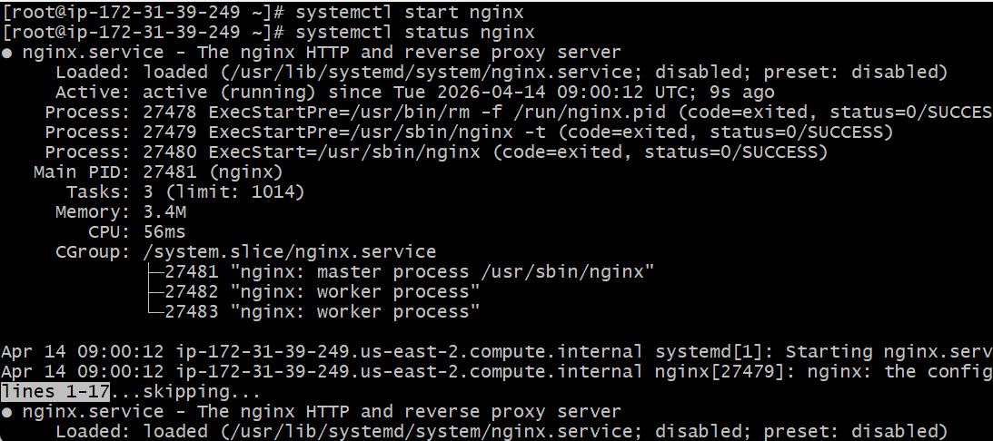
Browse with Server-2 Public IP address:80 it will work
HA-Proxy-Server Steps:
Run following command to Access HA-Proy-Server
ssh -i your-key.pem ec2-user@Pubipaddress of HA-Proxy-Server instance
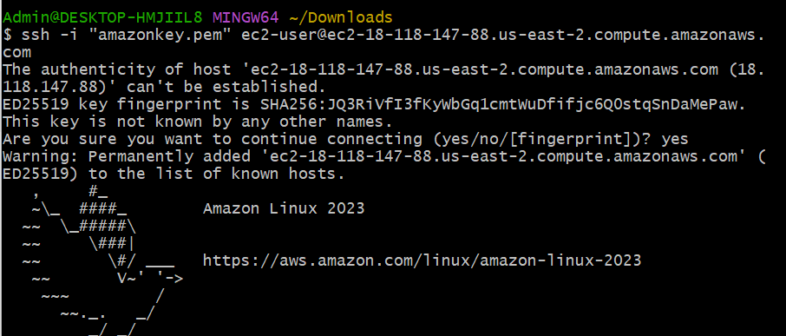
Sudo -i
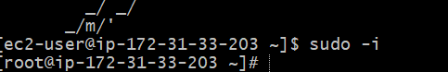
Yum update -y
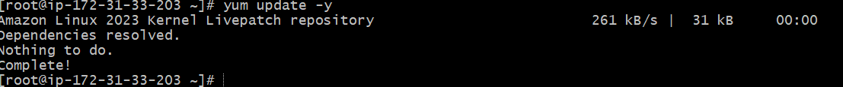
yum install haproxy -y
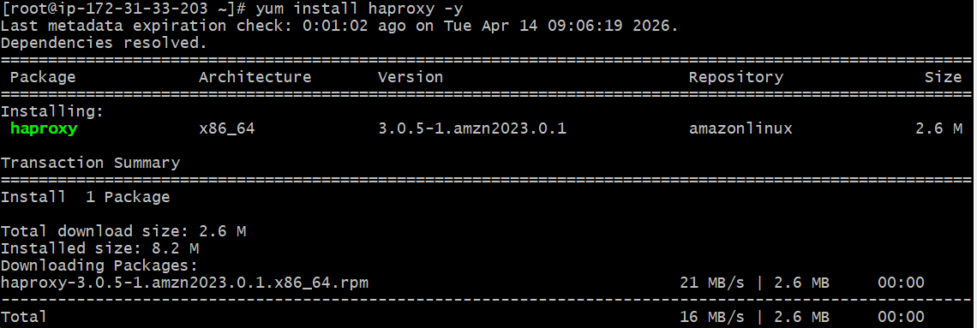
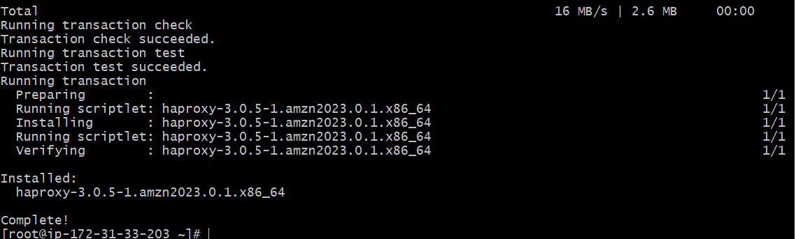
vi /etc/hosts
Add Server-1, Server-2 Public IP’s
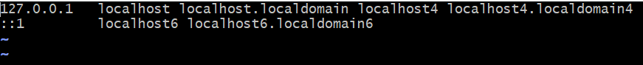
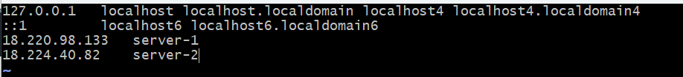
vi /etc/haproxy/haproxy.cfg
• Add Server-1, Server-2 public IP’s
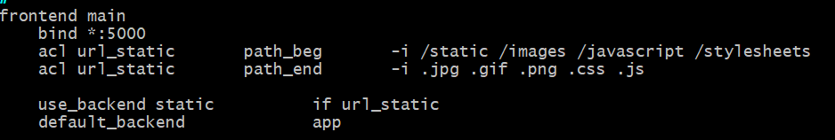
Change bind 5000 to 80 also add in backend server 1 and server 2 ip address mention red mark in changes
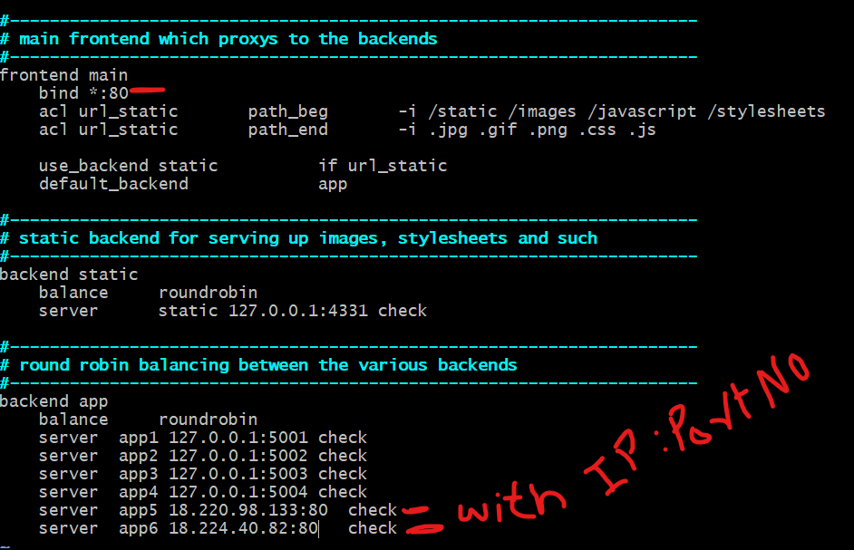
systemctl enable haproxy
systemctl start haproxy
systemctl status haproxy
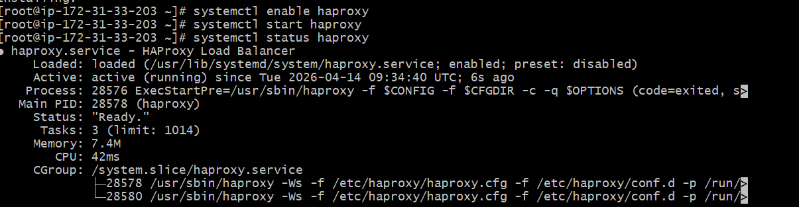
now browse with HA-Proxy-Server PublicIP:80 it will distribute load to Server-1, Server-2
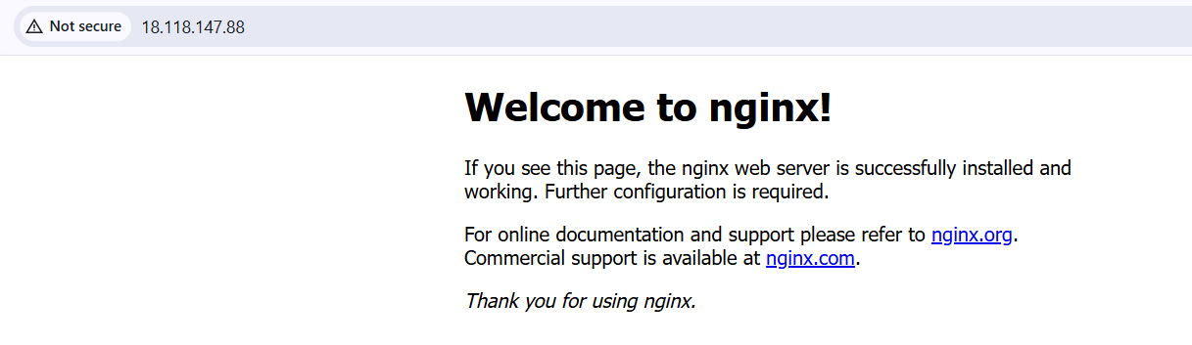
After refreshing so many time then it redirect server 2

